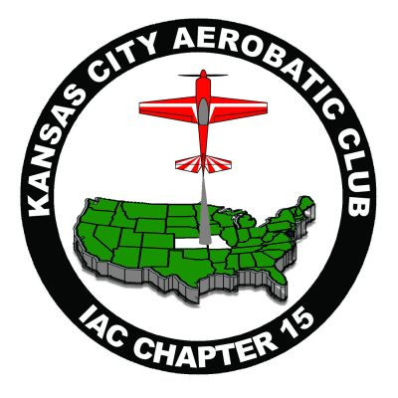
KANSAS CITY INTERNATIONAL AEROBATIC CLUB
AND
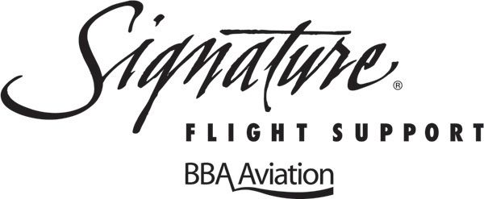
NEW CENTURY AIRPORT (KIXD)
FLY-IN/BREAKFAST
JUNE 15, 2013
OMELETS & PANCAKES
8:00AM – 10:00AM
AEROBATIC BOX OPEN TO IAC MEMBERS
9:00AM – 3:00PM
COME FLY & WATCH AEROBATICS OVER THE NEW CENTURY (KIXD) AIRPORT

